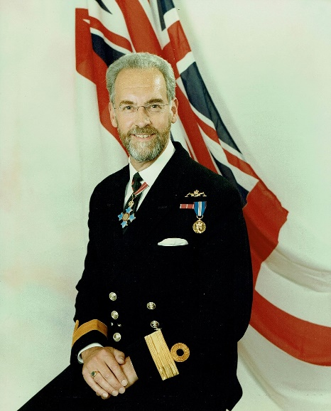
OBITUARY FOR COMMODORE LAURENCE (LAURIE) PHILLIP
BROKENSHIRE CBE RN
Laurie Brokenshire passed from this life on the 4th August 2017. He leaves behind his wife of 39 years, Ethel, four children, their spouses, and five grandchildren who Laurie always described as Grandelfs. Laurie was diagnosed with brain cancer in early 2016 as he and I planned and prepared for the UK’s hosting of the 2016 NATO Chess Championship. It was a shock to me, but Laurie was unflappable and told me that he would let me know if it became too difficult for him to assist. True to his word, Laurie guided my organising and we ran a successful tournament. Laurie was there at the opening ceremony and he and Ethel also attended the closing banquet, giving the customary magic display despite his illness.
Laurie Brokenshire was a truly great and remarkable man. Most of us go through life ruffling a few feathers; some of us could even be described as ‘Marmite’, loved by some, disliked by others. Laurie was not such a man and I can honestly say I never heard a bad word said about him. His love of all and his faith in God was unshakeable; his energy was boundless and his interests and expertise so wide ranging as to mark him out as a ‘Roy of the Rovers’ character.
Laurie was born in Plymouth; he studied maths at Exeter University and joined the Royal Navy in 1975. He rose to the rank of Commodore and retired after 28 years during which he commanded the shore establishments at Northwood and HMS Raleigh, the Royal Navy’s basic training centre for Ratings. He was awarded the CBE for his service in 2003. In retirement Laurie and Ethel fostered over 70 children and were extremely active in their local church. Laurie was also a member of the Navy Christian Fellowship.
Laurie’s list of achievements is quite astonishing. He was a member of the Inner Magic Circle; many of you will have seen him perform. Ethel described his magic circle examination as the most nervous he had ever been. Laurie was also a world-renowned puzzler and 3 rooms in his house were devoted to puzzles; the Daily Mail wrote about his collection. Laurie was also known for providing the third solution to something now known as the ‘Dudeney Loyd Brokenshire’ problem. The first two solutions were found over 100 hundred years ago, and it has since been discovered that there are no further solutions.

Laurie loved to sing; he sang on Songs of Praise on three occasions, he sang in choirs, he sang in barber shop quartets, and he sang with Ethel when they cycled, and they cycled quite a lot. Laurie and Ethel cycled and camped around Japan, the North Island of New Zealand, the East Coast of Australia, in Europe and 3 times across the United States.
Laurie ran the London Marathon, as did Ethel. He swam across the English Channel in 1986 and more recently he took up ice swimming, winning a gold medal in his age category at the 2016 UK ice swimming championships. Whilst terminally ill Laurie organised and swam in a family 30-mile relay between Fowey and Plymouth, raising over £45,000 for charity.

Dave Ross wrote: it is hard to find original words to describe Laurie. Almost everyone who knew him described him as inspirational and in a single word that is as close as I can get. The Reverend who conducted his thanksgiving service described him as the closest man to God he ever met. Those of you reading this will have met Laurie through chess and his role as President of the Combined Services Chess Association; I first remember meeting Laurie in 1989 at HMS Sultan. Later, when I was based at Northwood in 1992 (I think), Laurie organised matches in Greenwich and the Foreign and Commonwealth Office. In the latter of these, we became trapped in the building at the end of the match due to a bomb scare in Trafalgar Square. Most of the players were worrying about missing the last tube or train home, but Laurie took control and entertained the troops with an impromptu magic show; I don’t think anyone wanted to leave after 30 mins, he was a wonderful entertainer. I never saw Laurie fazed by anything and it is only in later years that I came to understand that that came from his faith in God. Laurie was a good chess player, but he was an exceptional man and I shall miss his guidance, advice and friendship. I am but one of thousands whose lives he touched and influenced; I feel so lucky to have met and known Laurie.

Steve O’Neill wrote: he was remarkable in so many ways. As the Chairman of the CSChA from 2000 to 2011, I was always able to count on his Presidential leadership and guidance; you never felt alone with Laurie at the helm. I first met Laurie 25 years ago at a Combined Services event in 1992 and feel blessed to have known him and to count him as my friend. Although it was sad to see him in May, clearly unwell, it was also a measure of the man that he came to see us all at such a difficult time. It was hard to say goodbye to him for the last time but I am so grateful that his courage allowed us all the chance to do so. He was deeply profound in his quiet wisdom and truly inspirational to so many of us during his lifetime. I, like so many of you reading this, will miss him more than mere words can say.

Carl Portman wrote: Attending Laurie’s funeral was one of the most important and thought-provoking days of my life. I thought that I knew Laurie but seeing the size of the congregation and hearing the stories of his life illustrated just how much Laurie did for people and just what a unique and irreplaceable human being he was. Laurie didn’t just do magic, he was magic and I shall miss him terribly. They say that the purpose of life is to have a life of purpose; well, Laurie certainly had that. I believe that he sprinkled a bit of stardust into the lives of anyone and everyone he ever met. Our chess games were always hard fought; our conversations (and emails) were always stimulating, and the puzzles Laurie asked me to do were always challenging. He was a man I looked up to – we all did. He has gone, yet he has not gone. He loved to sing whilst out cycling with Ethel and the following verse was a favourite (from ‘How great thou art’)

When through the woods and forest glades I wander
And hear the birds sing sweetly in the trees;
When I look down from lofty mountain grandeur
And hear the brook and feel the gentle breeze.

How apt. How lovely it is then to feel that when I am out and about on my own wanderings through life that I shall always carry a part of Laurie’s indefatigable spirit with me. Bright Blessings ‘Grandalf’ – and thank you for the magic.

May God bless you Laurie
Your friends,

Steve O’Neill
Chairman Combined Services Chess Association 2000-2011

Dave Ross
Chairman Combined Services Chess Association 2011-to date

Carl Portman
Open File Magazine Editor

